**Assignment 4**

**~~Important Notescd:~~**

* ~~This is an~~ **~~individual assignment.~~**
* ~~I will be checking for borrowed or copied assignments. All work is to be done from scratch, you may not use any templates or other assistances.~~
* ~~This assessment is out of 20 marks total.~~
* ~~The purpose of this assessment is to learn the server-side programming and database operations.~~
* ~~You are required to use Node.js, Express, EJS and MongoDB for this assignment.~~

# ~~Note:~~

# ~~In this assignment you have do server-side programming only using Express web application framework and store data into MongoDB. You can re-use some of your code from Assignment 2 or 3 if you want.~~

# Tasks:

~~In this assignment, you are to develop a web application for an online store. The type of store that you design, and its inventory is left to your discretion, but you are required to use a MongoDB database to store the form submissions.~~

1. ~~HTML Static Content - Web Form~~ **~~(1 mark)~~**
   * ~~The front end must collect~~ **~~all~~** ~~the information needed to mail out the purchased items to the customer. I have included a few in the wireframe which are mandatory and must be included in your form.~~
   * ~~At least 2 products should be available for purchase. The application’s business logic must handle the products correctly.~~
2. ~~Server-side programming using JavaScript, EJS, Express and Node.js~~
   * **~~No validations are required to be done on the server side for this assignment. If you have some validations already done and you are reusing code from your previous assignments, there is no need to remove those validations. You can submit your assignment with or without any validations. It is encouraged to submit the assignment with server-side validations.~~**
   * ~~Generate a receipt to give to the customer, including all the information entered by the user and the products bought. Use only server-side scripting for this. Do not use any client-side code for processing the form.~~ **~~(2 marks)~~**
3. ~~Save data to MongoDB~~
   * ~~Save all the data from the web form along with any calculated values to a MongoDB database~~ **~~(5 marks)~~**
4. ~~Retrieve data from MongoDB~~
   * ~~Create a new page that fetches and shows the orders from the MongoDB database in a tabular format of your choice.~~ **~~(5 marks)~~**
5. ~~Video demo explaining your code and showing the final execution of the assignment.~~ **~~Make sure to showcase all the features of your application like filling the form, submitting it to generate a receipt, show the data saved in MongoDB and then show the orders page where you fetch all the data and show in a table.~~** ~~For the video demo, you are not required to use your camera, but you can if you want. You are only required to record your screen and your voice explaining the solution.~~ **~~Please submit .mp4 files only.~~** ~~You can use Zoom/PowerPoint for doing that, but you can use any other software for recording the video too.~~ **~~(5 marks)~~**
6. ~~Programming Style, Standards and overall completion of the tasks.~~ **~~(2 marks)~~**

~~It is a good idea to practice conforming to a set of programming standards. Refer to the posted summary of the IT Standards posted in IT Programs > General Resources.~~

*~~You can choose the design, fonts and colors as per your preference as long as you fulfill the minimum requirements mentioned above. You can name your online shop as per your liking and the product names too.~~*

# Submissions:

To submit this assignment:

1. Place all of your code into a single folder. Zip this folder and submit the zipped file to eConestoga. No cover sheet is required for this assignment. A good way to make sure everything is correct; is to unzip the file you are submitting on a different location on your computer and making sure everything works.
2. **Upload the video explanation separately from your code zip file.** Please do not zip your video with the code. You may have to make a second submission for that as the dropbox only allows you to submit one file at a time. **Submit .mp4 files only for the video.**

**Note:** You can submit multiple times if you want. Please mention in comments which submission to evaluate. Also note that if you resubmit after the due date, late penalties apply as per your Program Handbook.

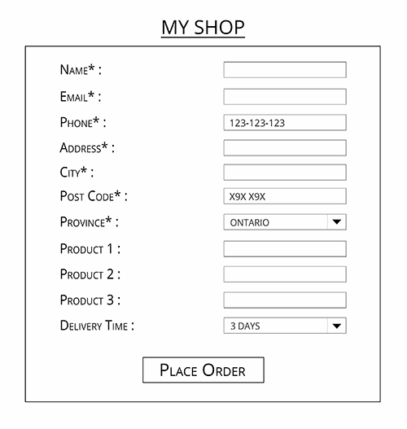

**Order form:**

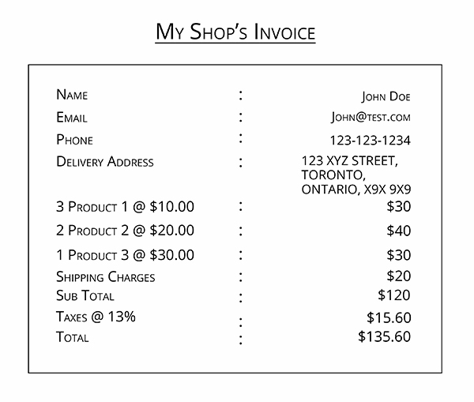**Receipt/Invoice:**

**All Orders:**

Show all the orders stored in the database in a tabular format.